LAB QUESTIONS – MySQL 21st November 2025

PART 1 — SQL Queries
Q1. Create a table named students with fields:
• stdid INT PRIMARY KEY
• stdname VARCHAR(50)
• age INT
• city VARCHAR(50)
ANSWER- 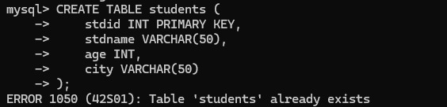
Q2. Insert the following records into the students table:
stdid stdname age city
1 Rohan 20 Pune
2 Meera 22 Mumbai
3 Arjun 21 Delhi
4 Kavya 23 Pune
5 Neha 22 Kolkata
ANSWER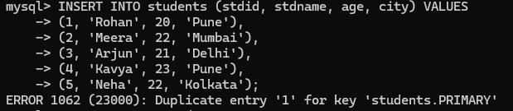

Q3. Display all student records.
ANSWER-
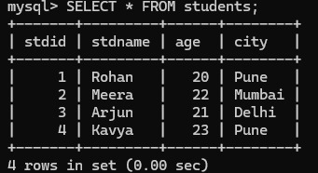
Q4. Display only the name and age of all students.
ANSWER-
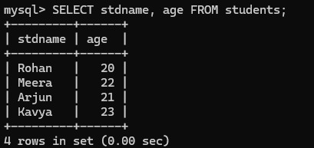
Q5. Display students who are from Pune.
ANSWER-
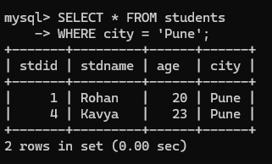

Q6. Display students whose age is greater than 21.
ANSWER-
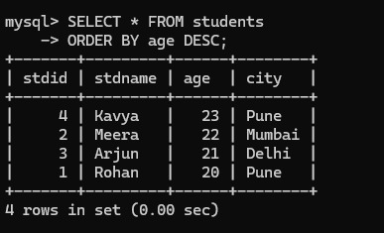

Q7. Display students in descending order of age.
ANSWER-

Q8. Count how many students belong to each city. (Use GROUP BY)
ANSWER-
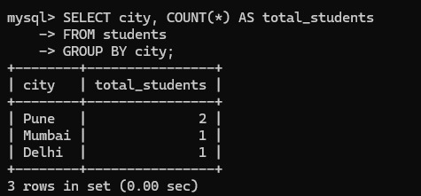

Q9. Display students whose name starts with ‘K’. (Use LIKE)
ANSWER-
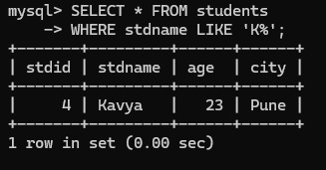

Q10. Delete student whose stdid = 5.
ANSWER-


PART 2 — JOIN PRACTICE
Tables:
students (stdid, student_name, city)
1 Rohan Pune
2 Meera Mumbai
3 Arjun Delhi
4 Kavya Pune

marks (stdid, subject, marks)
1 Maths 88
2 Maths 76
3 Maths 92
5 Maths 67

Q11. INNER JOIN — Display student name and marks of only those students who have matching IDs.
ANSWER-
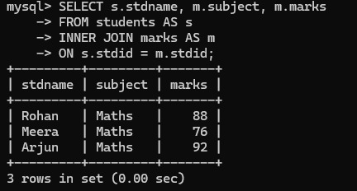

Q12. LEFT JOIN — Display all students and their marks (NULL if not available).
ANSWER-
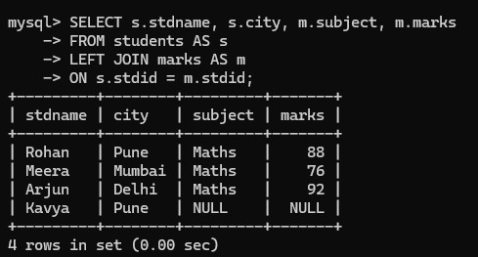
Q13. RIGHT JOIN — Display all marks records along with student names (NULL if student missing).
ANSWER-
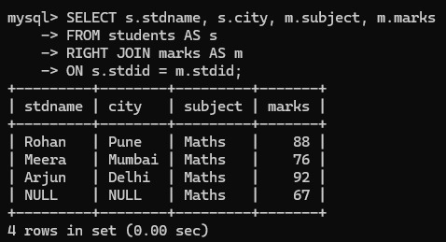

Q14. CROSS JOIN — Display all possible combinations of students and subjects.
ANSWER-
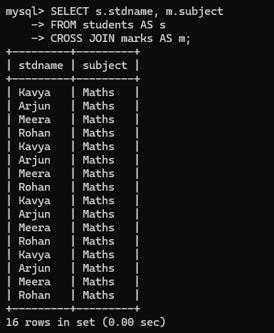
Q15. INNER JOIN with filtering — Display students who scored more than 80.
ANSWER-

